Task5 Wireshark_basic

5.1

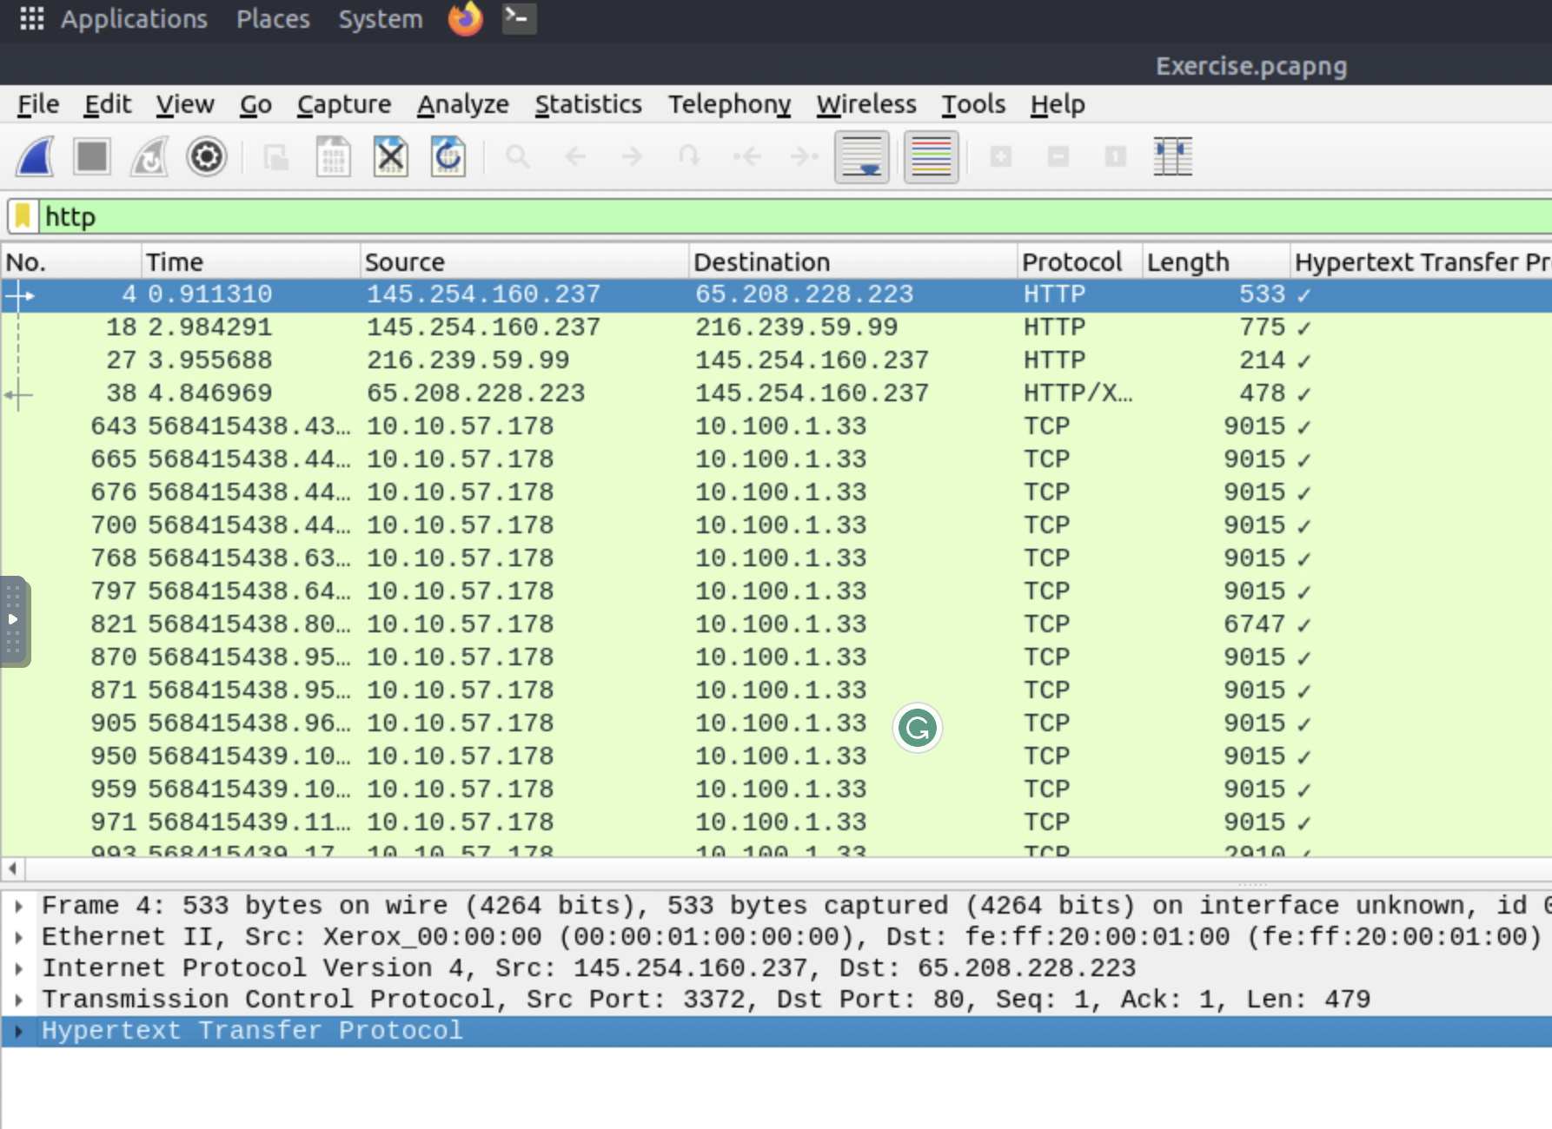

5.2

Right bottom of the screen shows the displayed packets

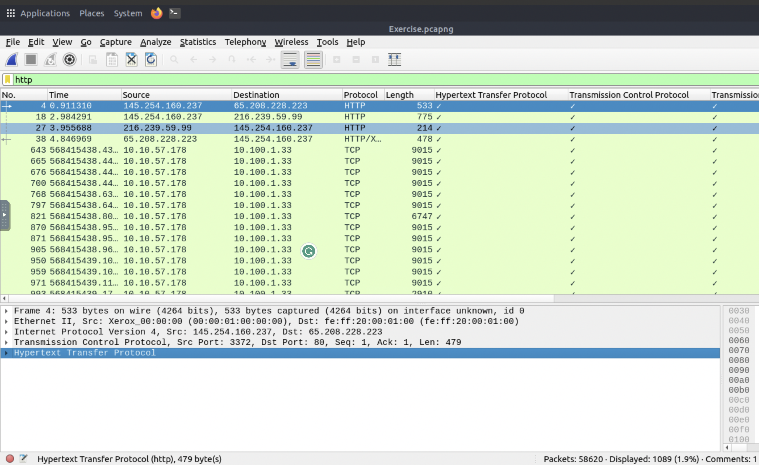

5.4

Use flow stream on the packet and look for artist in the find option

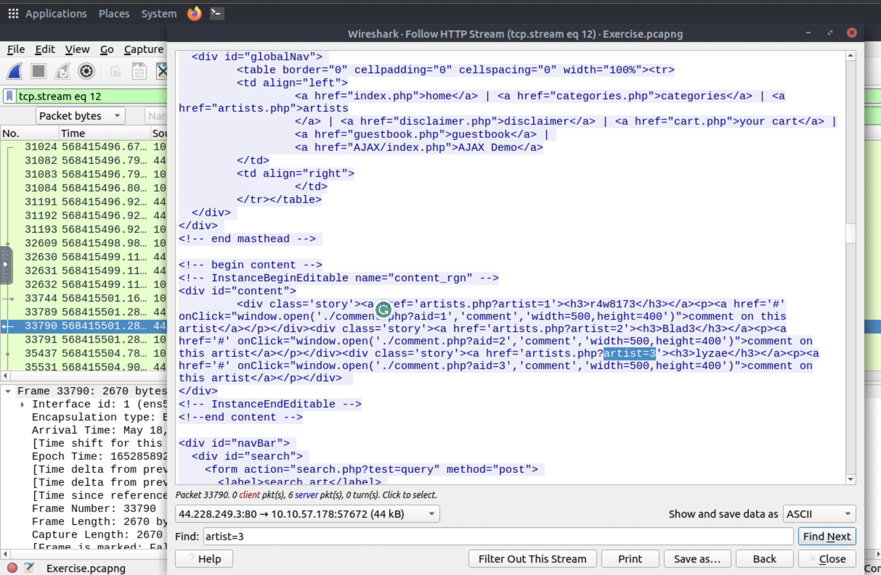

5.5

Use flow stream on packet and use find option to find artist=2

